Use Cases Description

For

Smart Mart System
(SMS)

Prepared by K15T1-Team11
Van Lang University
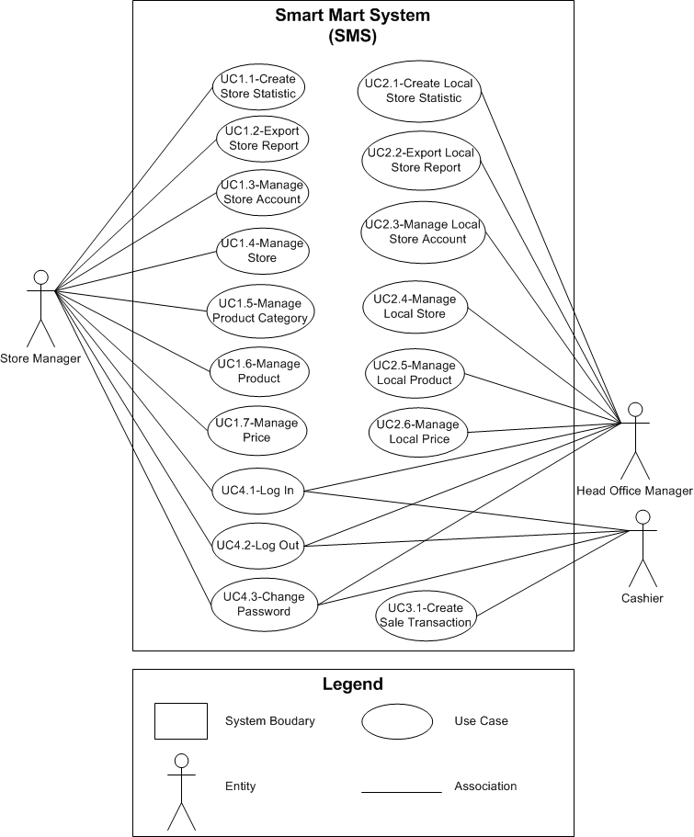

Table of Contents
UC1.1 – Create Store Statistic (NOT) 3
UC1.2 – Export Store Report (NOT) 4
UC1.3 – Manage Store Account (NOT) 5
UC1.4 – Manage Store (NOT) 6
UC1.5 – Manage Product Category (NOT) 6
UC1.6 – Manage Product (NOT) 7
UC1.7 – Manage Price (NOT) 8
UC2.1 – Create Local Store Statistic (NOT) 9
UC2.2 – Export Local Store Report (NOT) 9
UC2.3 – Manage Local Store Account (NOT) 10
UC2.4 – Manage Local Store (NOT) 11
UC2.5 – Manage Local Product (NOT) 12
UC2.6 – Manage Local Price (NOT) 12
UC3.1 – Create Sale Transaction (NOT) 13
UC4.1 – Log In 14
UC4.2 – Log Out 15
UC4.3 – Change Password 16

UC1.1 – Create Store Statistic (NOT)
Use Case Title: | Use Case ID:
General Use Case Description:

Entities Involved:

Preconditions:

Primary Use Case Flow of Events:
1.
N.
Primary Use Case Post Conditions:

Alternate Use Case #_____ Flow of Events:
1.
N.
Alternate Use Case #_____ Post Conditions:

UC1.2 – Export Store Report (NOT)
Use Case Title: | Use Case ID:
General Use Case Description:

Entities Involved:

Preconditions:

Primary Use Case Flow of Events:
1.
N.
Primary Use Case Post Conditions:

Alternate Use Case #_____ Flow of Events:
1.
N.
Alternate Use Case #_____ Post Conditions:

UC1.3 – Manage Store Account (NOT)
Use Case Title: | Use Case ID:
General Use Case Description:

Entities Involved:

Preconditions:

Primary Use Case Flow of Events:
1.
N.
Primary Use Case Post Conditions:

Alternate Use Case #_____ Flow of Events:
1.
N.
Alternate Use Case #_____ Post Conditions:

UC1.4 – Manage Store (NOT)
Use Case Title: | Use Case ID:
General Use Case Description:

Entities Involved:

Preconditions:

Primary Use Case Flow of Events:
1.
N.
Primary Use Case Post Conditions:

Alternate Use Case #_____ Flow of Events:
1.
N.
Alternate Use Case #_____ Post Conditions:

UC1.5 – Manage Product Category (NOT)
Use Case Title: | Use Case ID:
General Use Case Description:

Entities Involved:

Preconditions:

Primary Use Case Flow of Events:
1.
N.
Primary Use Case Post Conditions:

Alternate Use Case #_____ Flow of Events:
1.
N.
Alternate Use Case #_____ Post Conditions:

UC1.6 – Manage Product (NOT)
Use Case Title: | Use Case ID:
General Use Case Description:

Entities Involved:

Preconditions:

Primary Use Case Flow of Events:
1.
N.
Primary Use Case Post Conditions:

Alternate Use Case #_____ Flow of Events:
1.
N.
Alternate Use Case #_____ Post Conditions:

UC1.7 – Manage Price (NOT)
Use Case Title: | Use Case ID:
General Use Case Description:

Entities Involved:

Preconditions:

Primary Use Case Flow of Events:
1.
N.
Primary Use Case Post Conditions:

Alternate Use Case #_____ Flow of Events:
1.
N.
Alternate Use Case #_____ Post Conditions:

UC2.1 – Create Local Store Statistic (NOT)
Use Case Title: | Use Case ID:
General Use Case Description:

Entities Involved:

Preconditions:

Primary Use Case Flow of Events:
1.
N.
Primary Use Case Post Conditions:

Alternate Use Case #_____ Flow of Events:
1.
N.
Alternate Use Case #_____ Post Conditions:

UC2.2 – Export Local Store Report (NOT)
Use Case Title: | Use Case ID:
General Use Case Description:

Entities Involved:

Preconditions:

Primary Use Case Flow of Events:
1.
N.
Primary Use Case Post Conditions:

Alternate Use Case #_____ Flow of Events:
1.
N.
Alternate Use Case #_____ Post Conditions:

UC2.3 – Manage Local Store Account (NOT)
Use Case Title: | Use Case ID:
General Use Case Description:

Entities Involved:

Preconditions:

Primary Use Case Flow of Events:
1.
N.
Primary Use Case Post Conditions:

Alternate Use Case #_____ Flow of Events:
1.
N.
Alternate Use Case #_____ Post Conditions:

UC2.4 – Manage Local Store (NOT)
Use Case Title: | Use Case ID:
General Use Case Description:

Entities Involved:

Preconditions:

Primary Use Case Flow of Events:
1.
N.
Primary Use Case Post Conditions:

Alternate Use Case #_____ Flow of Events:
1.
N.
Alternate Use Case #_____ Post Conditions:

UC2.5 – Manage Local Product (NOT)
Use Case Title: | Use Case ID:
General Use Case Description:

Entities Involved:

Preconditions:

Primary Use Case Flow of Events:
1.
N.
Primary Use Case Post Conditions:

Alternate Use Case #_____ Flow of Events:
1.
N.
Alternate Use Case #_____ Post Conditions:

UC2.6 – Manage Local Price (NOT)
Use Case Title: | Use Case ID:
General Use Case Description:

Entities Involved:

Preconditions:

Primary Use Case Flow of Events:
1.
N.
Primary Use Case Post Conditions:

Alternate Use Case #_____ Flow of Events:
1.
N.
Alternate Use Case #_____ Post Conditions:

UC3.1 – Create Sale Transaction (NOT)
Use Case Title: | Use Case ID:
General Use Case Description:

Entities Involved:

Preconditions:

Primary Use Case Flow of Events:
1.
N.
Primary Use Case Post Conditions:

Alternate Use Case #_____ Flow of Events:
1.
N.
Alternate Use Case #_____ Post Conditions:

UC4.1 – Log In
Use Case Title: Log In | Use Case ID: UC4.1
General Use Case Description:
User can log in into system
Entities Involved:
Head Office Manager; Store Manager; Cashier
Preconditions:
User has an account
Primary Use Case Flow of Events:
1a. User presses the log in link  2a. User types in username* and password*  3a. User presses the log in button | 1b. System show “Log In” screen  3b. System checks validations and log in to the system  3b.1. System checks to ensure that the required information (*) is entered  3b.2. System checks to ensure that the account has been existed  3b.3. System checks to ensure that the entered name and password correctly  3b.4. System logs user into the system
N.
Primary Use Case Post Conditions:
User is logged in into the system
Alternate Use Case #__1__ Flow of Events: After step 3b.1 of primary flow
Enter required information Is not fully
1.
N.
Alternate Use Case #__1__ Post Conditions: System show message that “You must enter the username and password”
Alternate Use Case #__2__ Flow of Events: After step 3b.2 of primary flow
1.
N.
Alternate Use Case #__2__ Post Conditions: System show message that “This username is not exist in the system”
Alternate Use Case #__3__ Flow of Events: After step 3b.3 of primary flow
1.
N.
Alternate Use Case #__3__ Post Conditions: System show message that “The username or password is not correctly”

UC4.2 – Log Out
Use Case Title: Log Out | Use Case ID: UC4.2
General Use Case Description:
User can log out the system
Entities Involved:
Head Office Manager; Store Manager; Cashier
Preconditions:
User logged in the system
Primary Use Case Flow of Events:
1a. User presses the log out link | 1b. System logs out user
N.
Primary Use Case Post Conditions:
User is logged out the system
Alternate Use Case #_____ Flow of Events:
1.
N.
Alternate Use Case #_____ Post Conditions:

UC4.3 – Change Password
Use Case Title: Change Password | Use Case ID: UC4.3
General Use Case Description:
User can change their account password
Entities Involved:
Head Office Manager; Store Manager; Cashier
Preconditions:
User logged in the system
Primary Use Case Flow of Events:
1a. User presses the change password button  2a. User enters the Current password*, New password* and Confirm new password*  3a. User presses the save button | 1b. System show “Change Password” screen  3b. System checks validations and saves changes  3b.1. System checks to ensure that the required information is fully entered  3b.2. System checks to ensure that the Current password and New Password enters not match  3b.3. System checks to ensure that the New password and Confirm new password enters match  3b.4 System checks to ensure that the Current password enter is correct  3b.5. System changes the user password and saves changes
N.
Primary Use Case Post Conditions:
System shows the message that “The password is changed”
Alternate Use Case #__1__ Flow of Events: After step 3b.1 of primary flow
Enter required information Is not fully
1.
N.
Alternate Use Case #__1__ Post Conditions: System show message that “You must enter the required information”
Alternate Use Case #__2__ Flow of Events: After step 3b.2 of primary flow
Enter the Current password same as New password
1.
N.
Alternate Use Case #__2__ Post Conditions: System show message that “The Current password and New password must different”
Alternate Use Case #__3__ Flow of Events: After step 3b.3 of primary flow
Enter the New password and Confirm new password not correct
1.
N.
Alternate Use Case #__3__ Post Conditions: System show message that “The New password and Confirm new password not correct”
Alternate Use Case #__4__ Flow of Events: After step 3b.4 of primary flow
Enter the Current password is not correct with database
1.
N.
Alternate Use Case #__4__ Post Conditions: System show message that “The Current password is not correctly”

